CAS PY 106

In-class note 18

1. Faraday’s Law of induction
2. Ɛ = - N \* delta O / delta t
3. O = BA\*cos(theta)
4. Faraday’s Law Example
5. 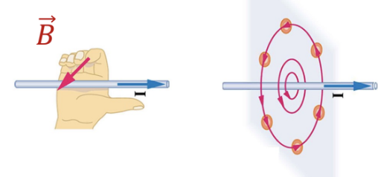
6. 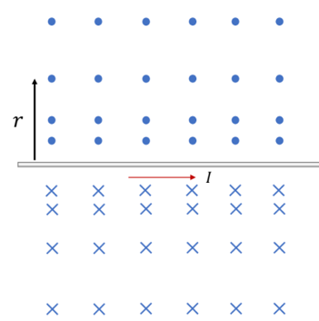
7. 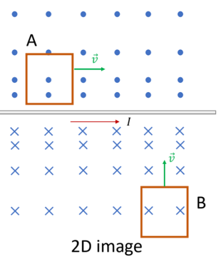
8. Which loop will the magnetic flux increase over time?

Loop B 🡪 Loop B moves closer to the wire, and the B-field gets stronger over time: O = BA \* cos(theta)

If there’s a change in flux, there’s an induced voltage (Faraday’s Law)

1. Graphs and Faraday’s Law of induction
2. The graph of magnetic flux through a circular coil is plotted as a function of time. The coil has N = 5 loops. What does this graph tell us about the induced emf, Ɛ?
3. 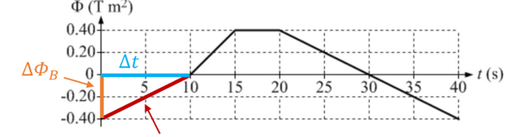
4. 0-10 seconds

Ɛ = -5 \* .4/10 = -0.20V

Ɛ = IR

I = Ɛ/R = .2/10 = 0.02A

1. 10-15 seconds

Ɛ = -5 \* .4/5 = -0.40V

Ɛ = IR

I = Ɛ/R = .4/10 = 0.04A

1. 15-20 seconds

Ɛ = -5\*0 = 0

1. 20-40 seconds

Ɛ = -5\*(-0.8/20) = 0.2V

Ɛ = IR

I = Ɛ/R = 0.2/10 = 0.02A

1. Lenz’s Law
2. If we can induce a voltage emf, Ɛ in the loop, then we can generate a current if we complete the circuit

I = Ɛ/R

1. Which way does the current go in the loop?
2. Lenz’s Law in simple terms:
3. “nature abhors a change in flux”
4. “the induced current tries to cancel the change in flux”
5. Lenz’s Law: A changing magnetic flux induces an emf that produces a current which sets up a magnetic field that ends to oppose whatever produced the change, which is why there is a negative sign in front of emf equation
6. Visualizing the two magnetic fields
7. 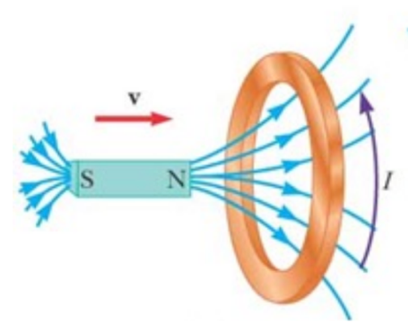
8. There exists magnetic flux go the right from the north pole of the magnetic field
9. 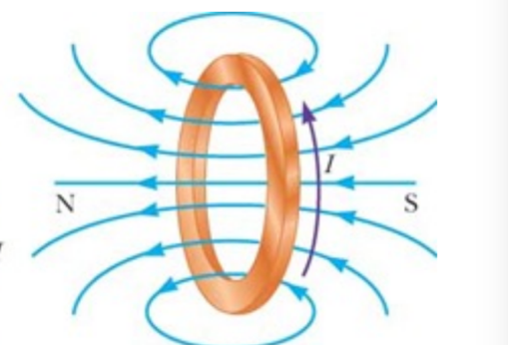
10. This second magnetic field comes from the current through the loop as if it’s another “bar magnet” (use right hand curl rule)
11. Since there is magnetic field going to the right into the area, there also exists a magnetic field that tries to oppose the field (since it doesn’t like to feel change) made by the moving charges (current)
12. Which direction will the induced current flow?
13. 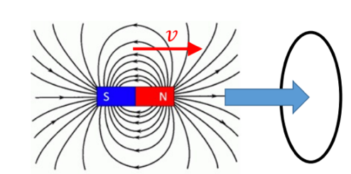
14. 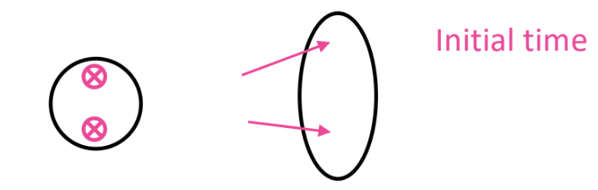
15. If we look directly into the loop we would see the field lines as shown here
16. 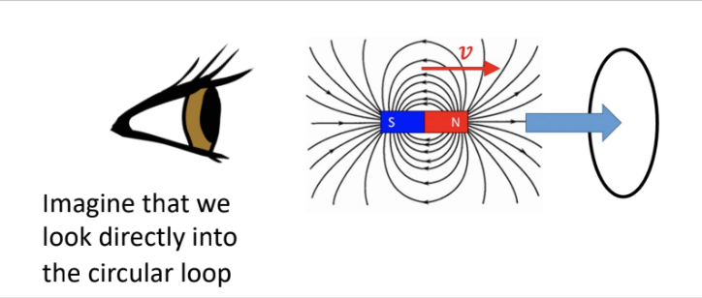
17. 
18. 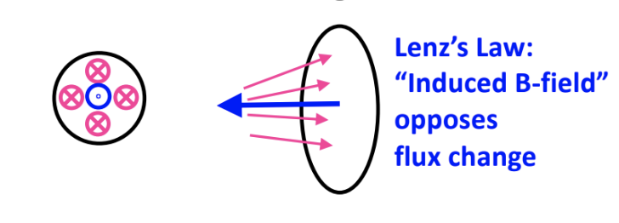
19. Using the second right hand rule and imagining that we look directly into the circular loop, magnetic fields are moving clockwise
20. To oppose this, magnetic fields should be created to move counterclockwise according to Lenz’s Law and we can use the second right hand rule
21. Lenz’s Law example
22. Wire loop is located near a long straight current-carrying wire. The current in the wire is directed to the right. With the current held constant in the long straight wire, the loop is moved up, away from the wire
23. 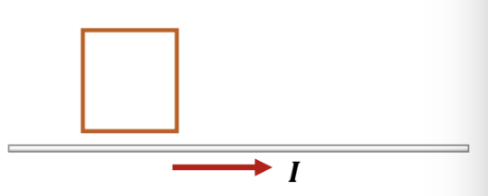
24. What direction is the induced current in the loop?

The induced current is counter-clockwise